Figure C-1. Hell Hole Reservoir aerial view downstream of dry bed from confluence of Rubicon River and Five Lakes Creek, fall 2007. Polygons demarcate areas with visible tree stumps that indicate near original ground surface elevation, or exposed bedrock areas that indicate no change from pre-dam ground elevations.
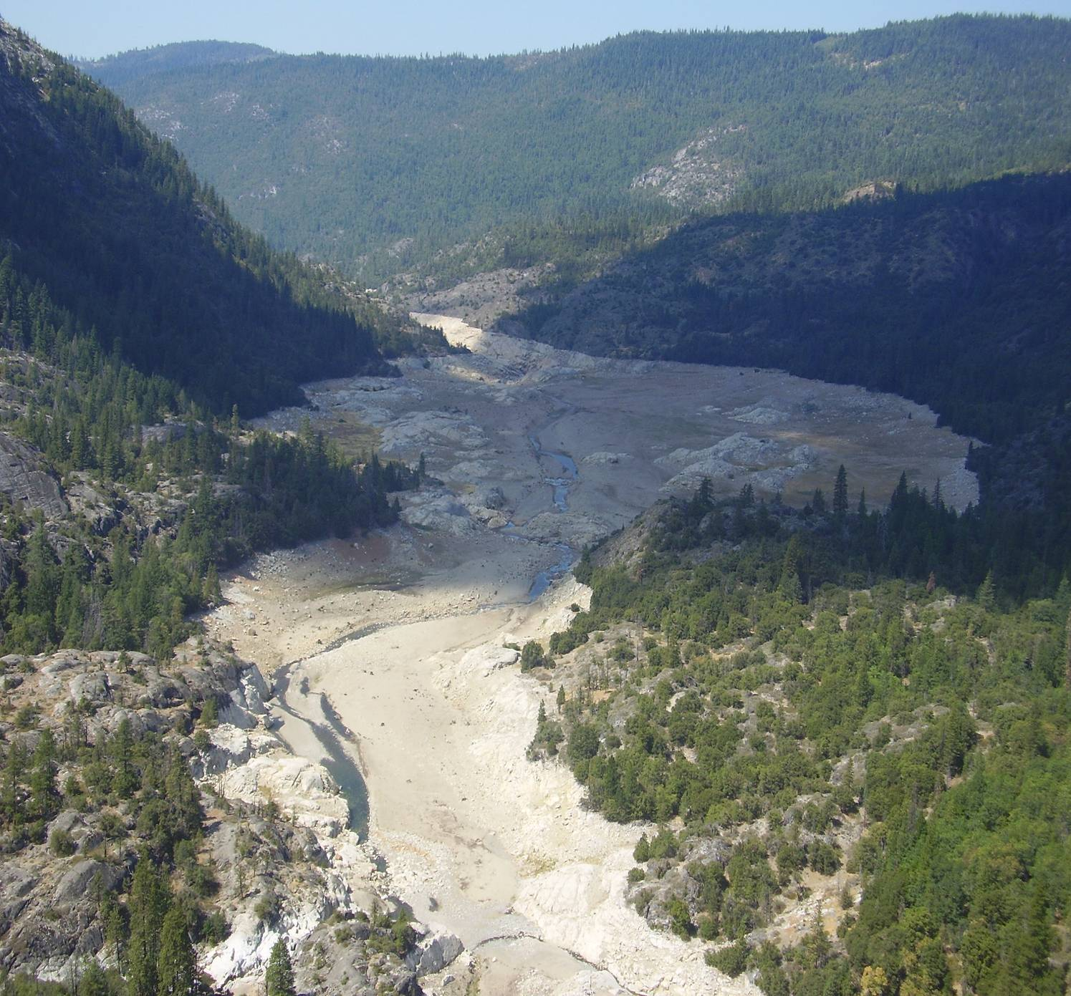
Confluence Rubicon and Five Lakes Ck
Tree stumps
Tree stumps
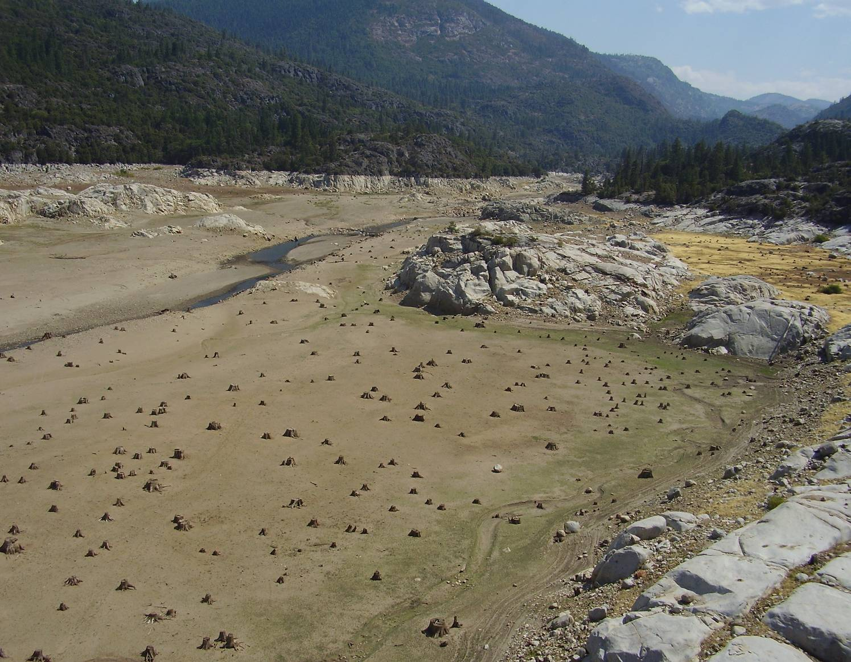
Figure C-2. Hell Hole Reservoir - view upstream from lower half of exposed bed at low-stand in summer 2007. Many old tree stumps (right side of Rubicon River) and bedrock exposures (both sides of Rubicon River) demarcate near pre-dam ground elevations, indicating relatively little sediment deposition.
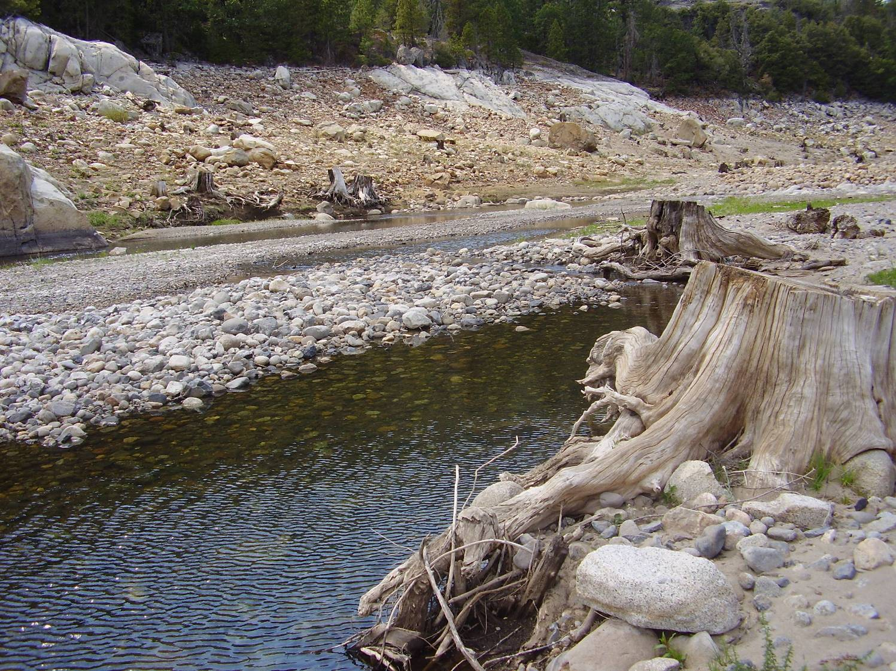
Figure C-3. Tree stumps on banks and in channel bed demarcating pre-dam elevations, fall 2007.
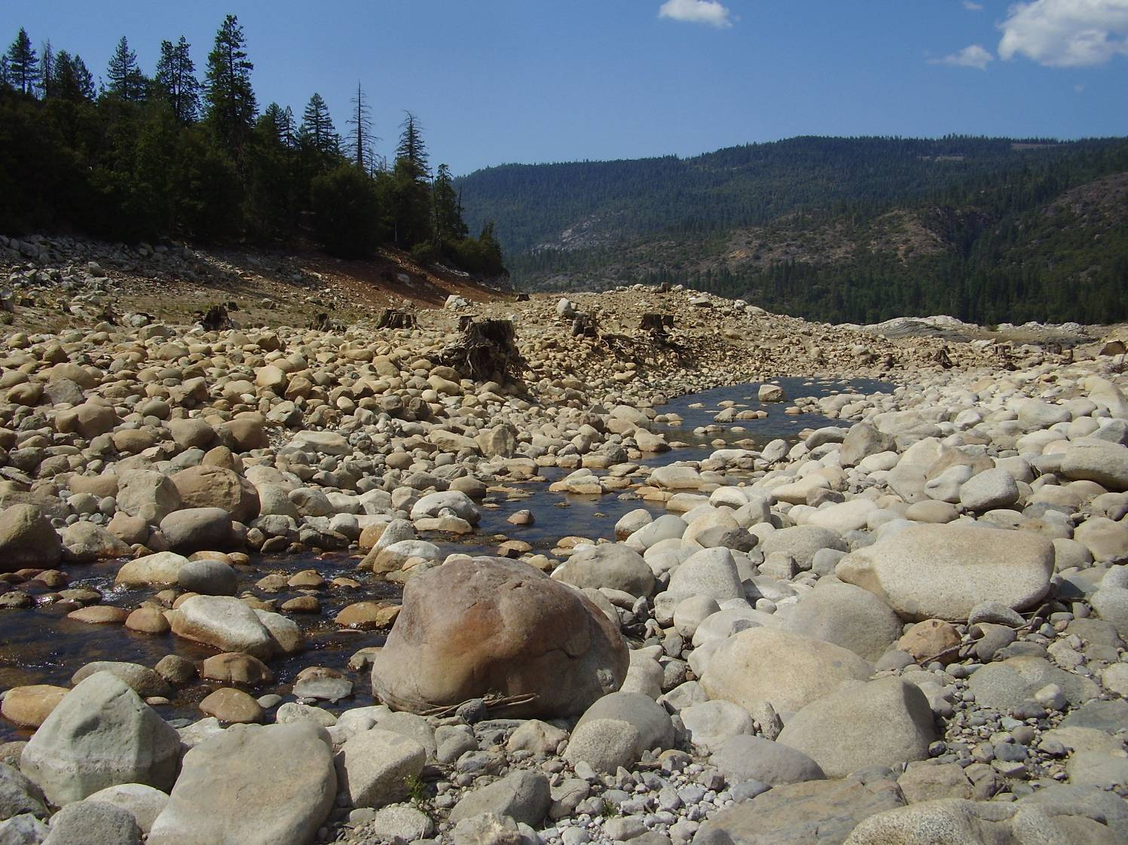
Figure C-4. Section of Rubicon River in Hell Hole Reservoir summer 2007, view facing downstream. Tree stumps on left side of river demarcate original bed elevations. Note that trees are situated on cobble-small boulder bed material, which likely indicates that a layer of soil has been stripped from the reservoir surface.
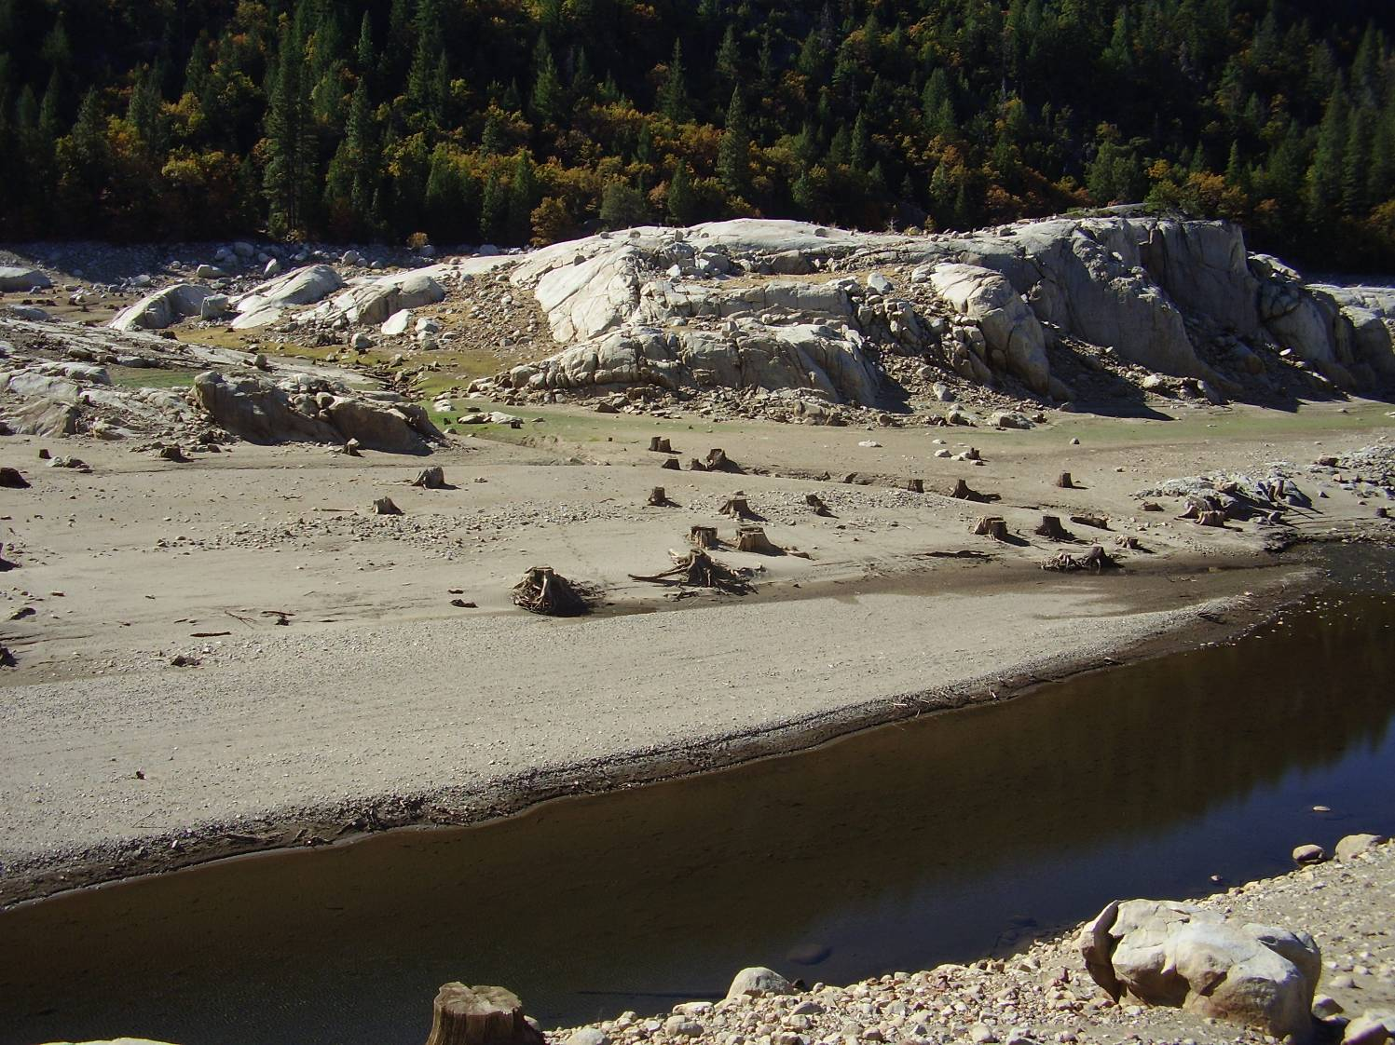
Figure C-5. Section of Rubicon River a few thousand feet downstream from inlet to Hell Hole Reservoir, view facing downstream. This section of river channel appears to have small areas of aggraded material, as indicated by the “bars” of sediment, and also by a lack of pools (probably former pools in-filled with sediment). The bars in this section contain gravel and sand. Note the tree stumps along left edge of channel at top of bank, an indicator of little change from pre-dam bed elevations.
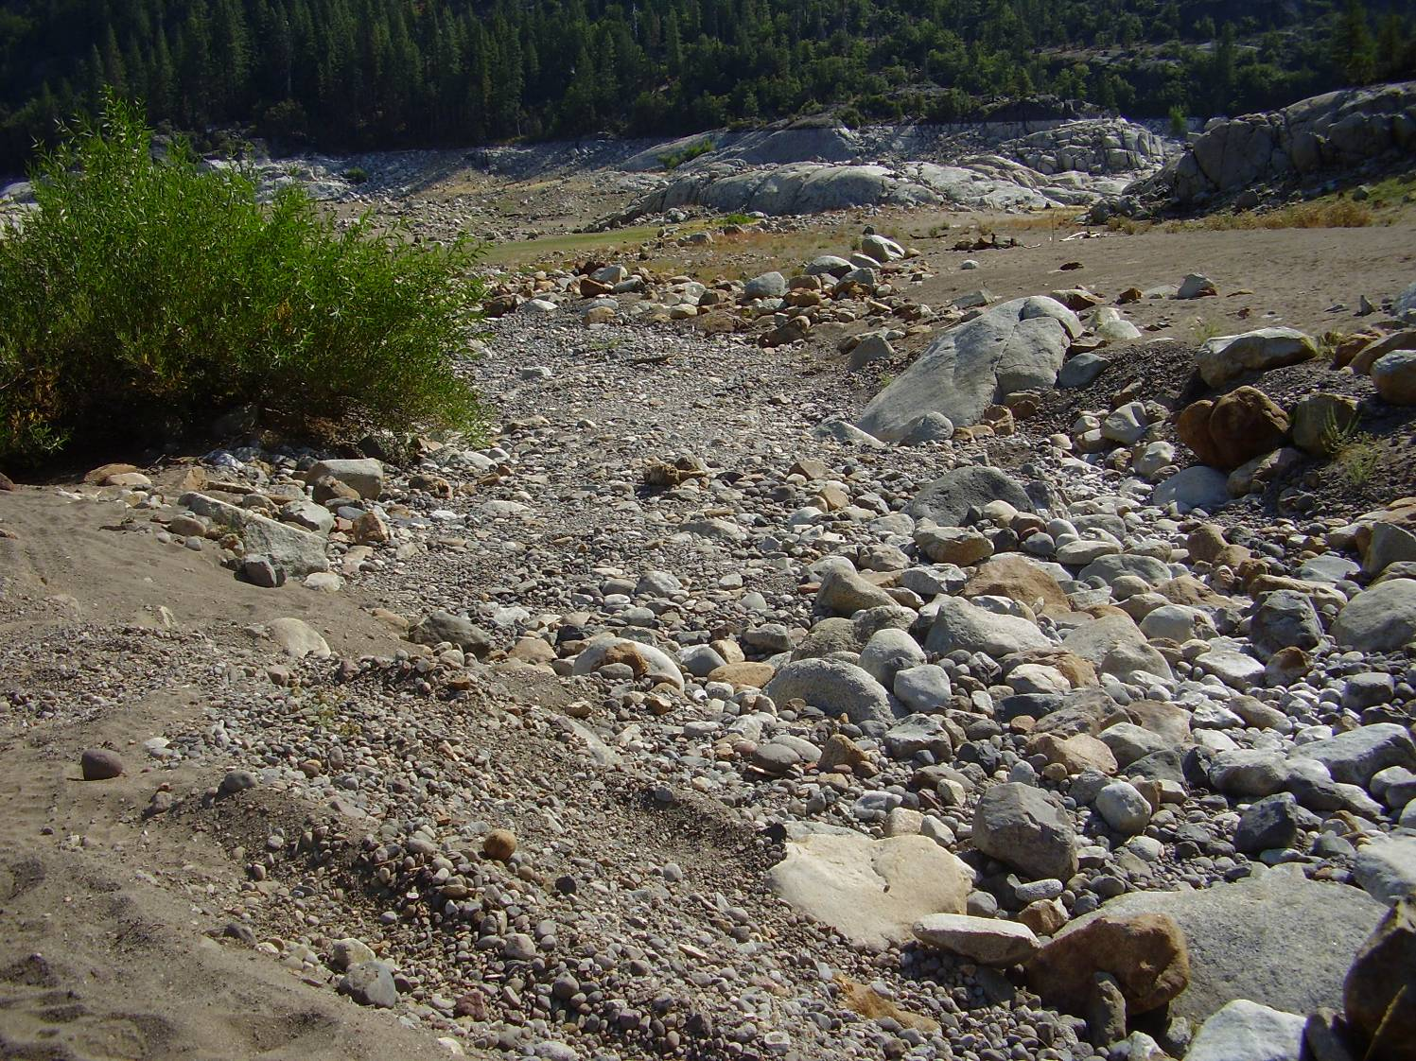
Figure C-6. This is a small, un-named tributary where it enters Hell Hole Reservoir near Grayhorse Creek, just below full pool elevation (view downstream). Note the accumulation of sand, gravel, and cobble size material within the discernable tributary channel.
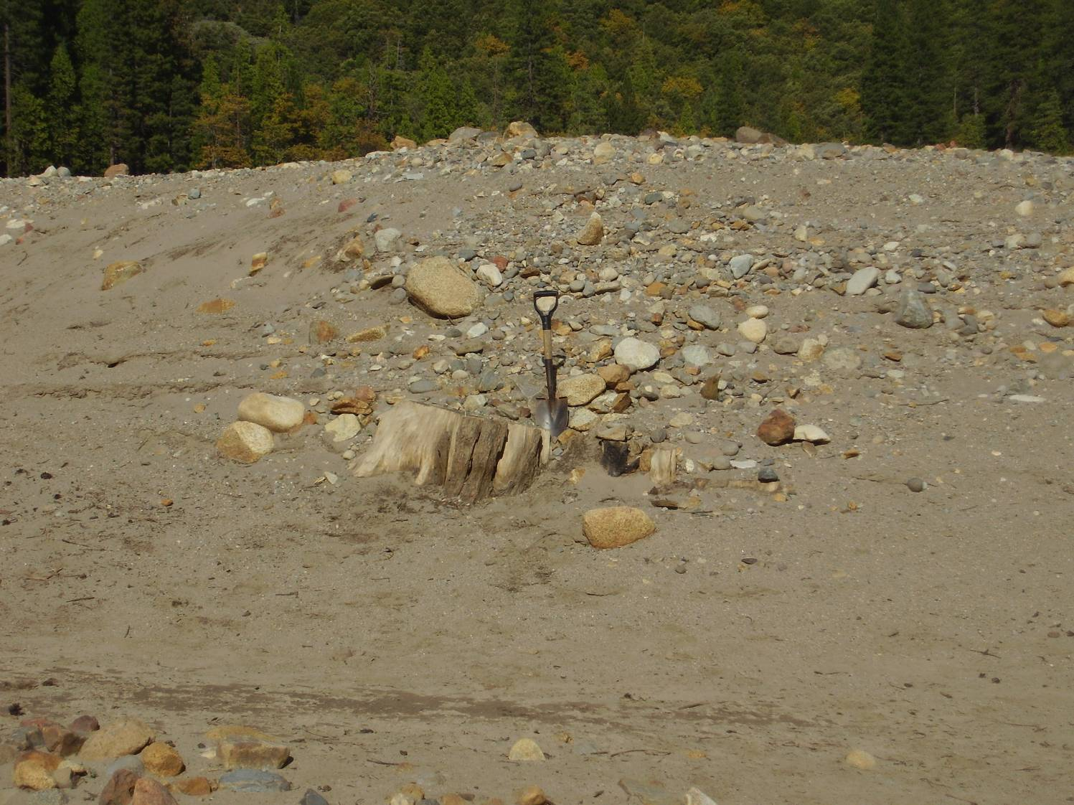
Figure C-7. Tree stump buried with about 3 feet of sediment. This located in the widest section of the sediment study area on the north side of the Rubicon River down-slope from where Grayhorse Creek enters Hell Hole Reservoir. Note the distinct delta-wedge shape of sediment that is building up over time and is pro-grading toward the Rubicon River.

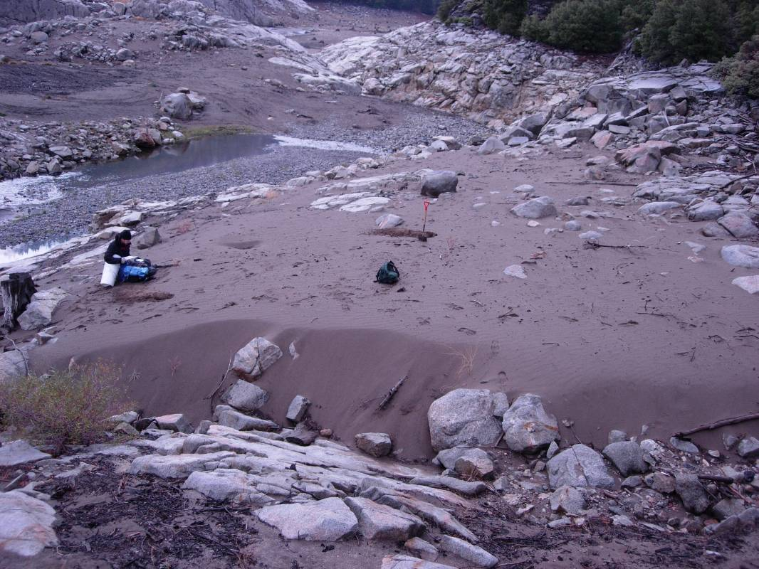
Figure C-8. Representing an area with 100% sand.
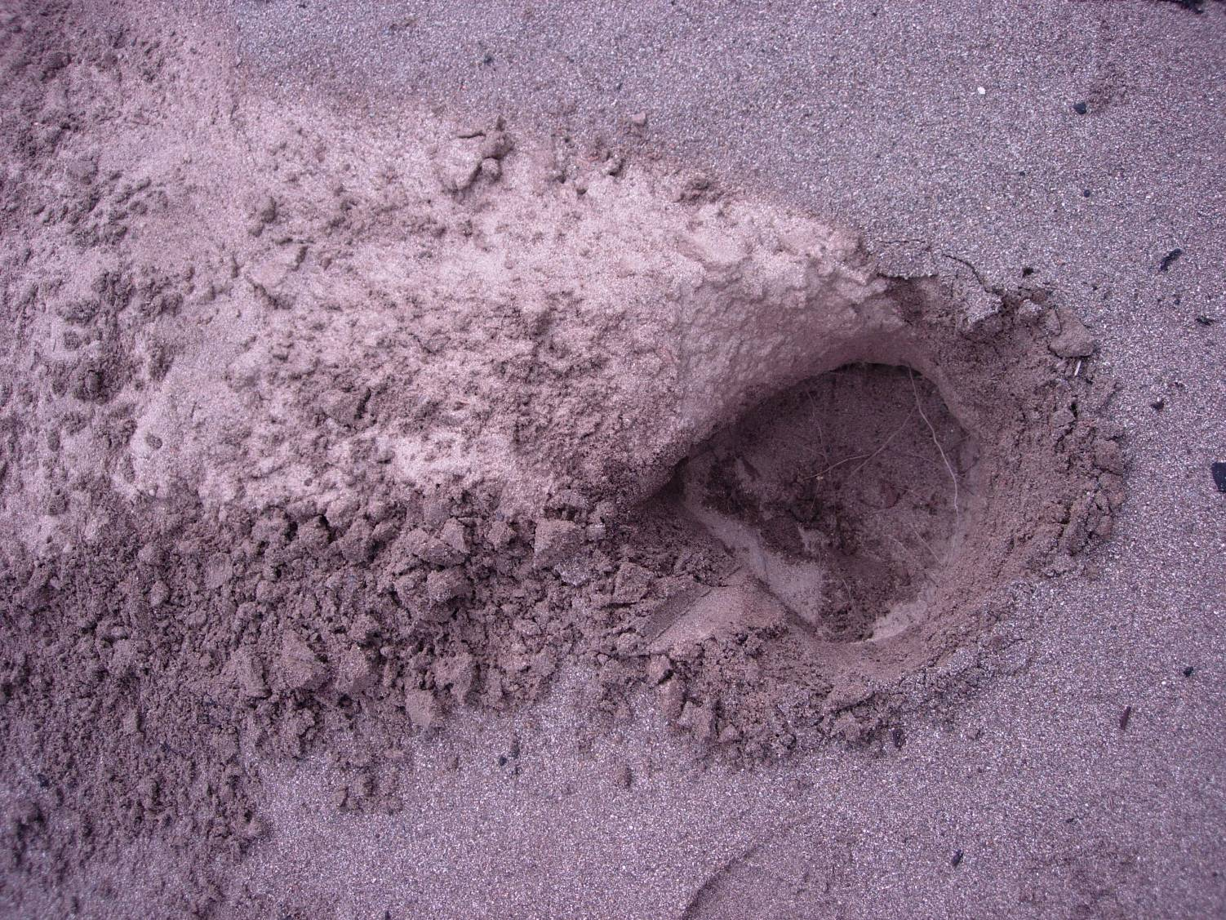
Figure C-9. Soil pit indicating 100% sand.

